

Infosys Springboard Virtual Internship 7.0
Completion Report
AI-Based Donation Management System for Intelligent Resource Matching and Distribution
Donation AI

Team Details

Particulars | Details
Batch Number | 3
Start Date | 19 August 2026
Names | Pallamala Sri Sai Teja
Internship Duration | 8 Weeks

1. Project Title
AI-Based Donation Management System for Intelligent Resource Matching and Distribution
The project, titled Donation AI, is an AI-enabled web application designed to improve the process of donating, matching, collecting and receiving useful resources. The system connects donors with NGOs through a centralized digital platform. It uses artificial intelligence to identify donated items from images and compares the detected items with the actual requirements registered by NGOs.
The platform provides separate interfaces for Donors, NGOs and Administrators, allowing each role to perform its respective activities while sharing a common donation lifecycle.

2. Project Objective
The primary objective of Donation AI is to create an intelligent and structured platform that simplifies the complete donation process, making it more organized, transparent, traceable and technology-driven. The project aims to:
- Allow donors to register donations digitally and upload item images.
- Identify donated items using AI-based image detection and present the detected items to the donor.
- Match donated items with the requirements registered by NGOs.
- Allow NGOs to maintain a demand registry and manage donation requests.
- Provide packaging, pickup scheduling and donation tracking through defined lifecycle stages.
- Provide secure delivery verification using OTP and photo verification.
- Maintain NGO inventory after donations are received.
- Provide administrators with centralized monitoring and management.
- Provide notifications for important donation events and support multiple languages.
- Provide responsive access across desktop and mobile devices, including Progressive Web Application functionality.

3. Project Description in Detail
Donation AI is a full-stack web application developed to manage the complete lifecycle of a donation, from registration to receipt by the NGO. In a conventional donation process, donors may not know which organization needs a particular item, while NGOs may find it difficult to identify and coordinate available resources. Donation AI addresses this problem by creating a digital connection between donors and NGOs.
A donor registers a donation and uploads an image of the item. The image is processed by a YOLOv8-based detection system, which identifies relevant objects and returns information such as item category, confidence, quantity where supported, and bounding-box coordinates. This information is associated with the donation record and compared against the requirements maintained in the NGO Demand Registry to identify potential NGO matches.
After matching, the donation moves through a structured lifecycle involving packaging, pickup scheduling, pickup confirmation, collection, delivery verification and NGO receipt. An administrative interface allows monitoring of users, NGOs, donations, AI detection records, reports and audit information.

Technologies Used
Area | Technologies
Frontend | React.js, Vite, HTML, CSS, JavaScript
Backend | Python, FastAPI, REST APIs, SQLAlchemy
Database | PostgreSQL
Artificial Intelligence | YOLOv8
Authentication | Firebase Authentication
Email | SMTP (Gmail SMTP)
Internationalization | i18next, react-i18next
Progressive Web App | vite-plugin-pwa
Development and Deployment | Docker, Docker Compose, Git, GitHub

System Workflow
The donation process operates through the following stages, from donor registration to inventory update at the NGO.
Step | Stage | Description
1 | Donation Registration | The donor creates a donation record.
2 | Image Upload | The donor uploads an image of the item.
3 | AI Item Detection | YOLOv8 analyses the image and detects items.
4 | NGO Demand Matching | Detected items are compared with NGO demand.
5 | NGO Selection / Request | A suitable NGO is selected and a request is raised.
6 | Packaging | The donor prepares the items using the packaging checklist.
7 | Pickup Scheduling and Confirmation | A pickup slot is scheduled and confirmed.
8 | Collection | The donation is collected from the donor.
9 | Delivery Verification | Delivery is verified using OTP and a delivery photo.
10 | NGO Received and Inventory | The donation is marked received and added to NGO inventory.
The Administrator oversees this lifecycle through dedicated views for users, NGOs, donations, AI detection records, reports and audit logs.

System Architecture
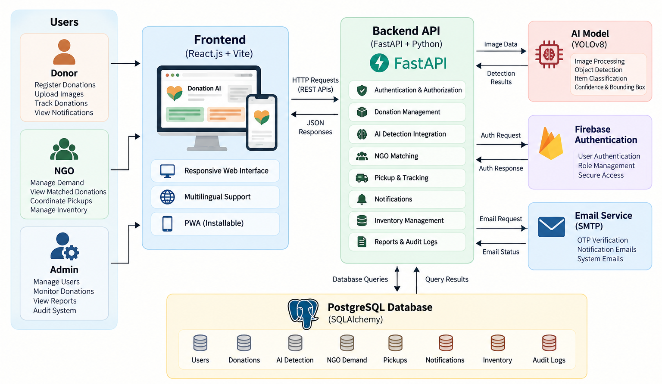
Figure 1: Overall Donation AI System Architecture
The architecture shows the interaction between the React frontend, FastAPI backend, PostgreSQL database, YOLOv8 model, Firebase Authentication and SMTP service, supporting role-based interfaces over a common backend and database.

Major Project Modules
Module | Description
Donor | Create donations, upload item images, view AI detection results and NGO matches, manage packaging, schedule pickups, track donations, receive notifications and manage the profile.
AI Detection | Uses YOLOv8 to analyse uploaded images and return item information, confidence values, quantities where applicable and bounding boxes.
NGO Matching | Compares detected donation information with NGO demand information and provides relevant NGO recommendations.
NGO | Maintain requirements, manage donation requests, coordinate pickups, verify deliveries, manage received resources and maintain inventory.
Pickup and Tracking | Manages pickup slots, scheduling, confirmation, collection and donation status tracking.
Delivery Verification | Uses OTP and photo verification before a donation is marked as delivered.
Admin | Centralized monitoring of users, NGOs, donations, AI detection records, reports and audit logs.
Notification | Informs users about important events throughout the donation lifecycle.
Multilingual | Supports English, Telugu, Hindi, Tamil and Kannada.
Progressive Web App | Provides installation, service worker support, caching and standalone application behavior.

4. Timeline Overview
Week | Activities Planned | Activities Completed
Week 1 | Requirement analysis and project planning | Problem identification, requirements analysis, user roles and project workflow finalized
Week 2 | System architecture and database design | Application architecture, PostgreSQL database structure, entities and relationships designed
Week 3 | Frontend and authentication | React interfaces, navigation, role-based pages and authentication integrated
Week 4 | Backend and API development | FastAPI backend, REST APIs, SQLAlchemy integration and database connectivity implemented
Week 5 | AI and NGO matching | YOLOv8 detection and NGO demand-based matching integrated
Week 6 | Donation lifecycle | Packaging, pickup scheduling, tracking, notifications and delivery workflow implemented
Week 7 | Additional features and testing | OTP, SMTP, multilingual support, responsive UI and PWA functionality implemented and tested
Week 8 | Final testing and documentation | Integration testing, debugging, regression testing, screenshots, documentation and final project preparation completed

5a. Key Milestones
The internship was run as four milestones, each supported by coordinator calls for technical guidance and status review. The key milestones and the dates on which they were achieved are listed below.
Milestone | Description | Date Achieved
Project Kickoff | Kick-off call, introduction to AI usage and a brief discussion of the project; requirements and problem definition finalized | 19 August 2026
Prototype / First Draft | Milestone 1 (25 August – 1 September 2026) completed; initial project workflow established | 1 September 2026
Mid-Term Review | Milestone 2 (2 – 15 September 2026) completed; core donation and AI workflow demonstrated | 15 September 2026
Final Submission | Milestone 3 (16 – 29 September 2026) completed; technical completion of the project and final review, with the documentation and presentation template shared | 30 September 2026
Presentation | Presentation and demo prepared through three mock sessions (6, 8 and 12 October 2026); project closure call | To be confirmed

5b. Project Execution Details
The project was executed through an iterative development process. The initial stage focused on understanding the donation problem and defining the roles of Donor, NGO and Admin. The system architecture and database structure were then planned to support the complete donation lifecycle.
The frontend was developed using React.js, while FastAPI was used to implement the backend services, with PostgreSQL as the main database. After the core application was in place, AI-based item detection was integrated using YOLOv8 and connected to the donation management system, so that uploaded donation images could be processed and associated with the corresponding donation. NGO demand management and matching were then added to connect donated items with NGO requirements.
The project was subsequently extended with packaging, pickup scheduling, status tracking, notifications, delivery verification, inventory management, multilingual support, responsive design and PWA functionality. Finally, the application was tested module by module and then through complete end-to-end workflows.

Database Design
PostgreSQL was used as the primary relational database. It manages the relationships between users, donors, NGOs, donations, AI detections, demand information, pickups, notifications, inventory, status history and administrative records.
Data Entity | Purpose
Users, Donors, NGO Profiles, Admins | Account and role information for Donors, NGOs and Administrators
Donations | Donation records registered by donors
Donation Status History | Lifecycle transitions of each donation
AI Detection Records | Items, confidence and quantities detected from donation images
NGO Demand | Resource requirements registered by NGOs
Donation Requests / Matches | Association between donations and NGOs
Pickups | Pickup slots, scheduling and pickup status
Delivery / OTP Information | Delivery verification data
Notifications | Event notifications for users
Inventory | Resources received by NGOs
Audit Logs | Administrative and activity records
A donor is associated with one or more donations, and each donation is linked to its AI detection, NGO match, pickup and status history. An NGO is associated with its demand, donation requests and inventory.
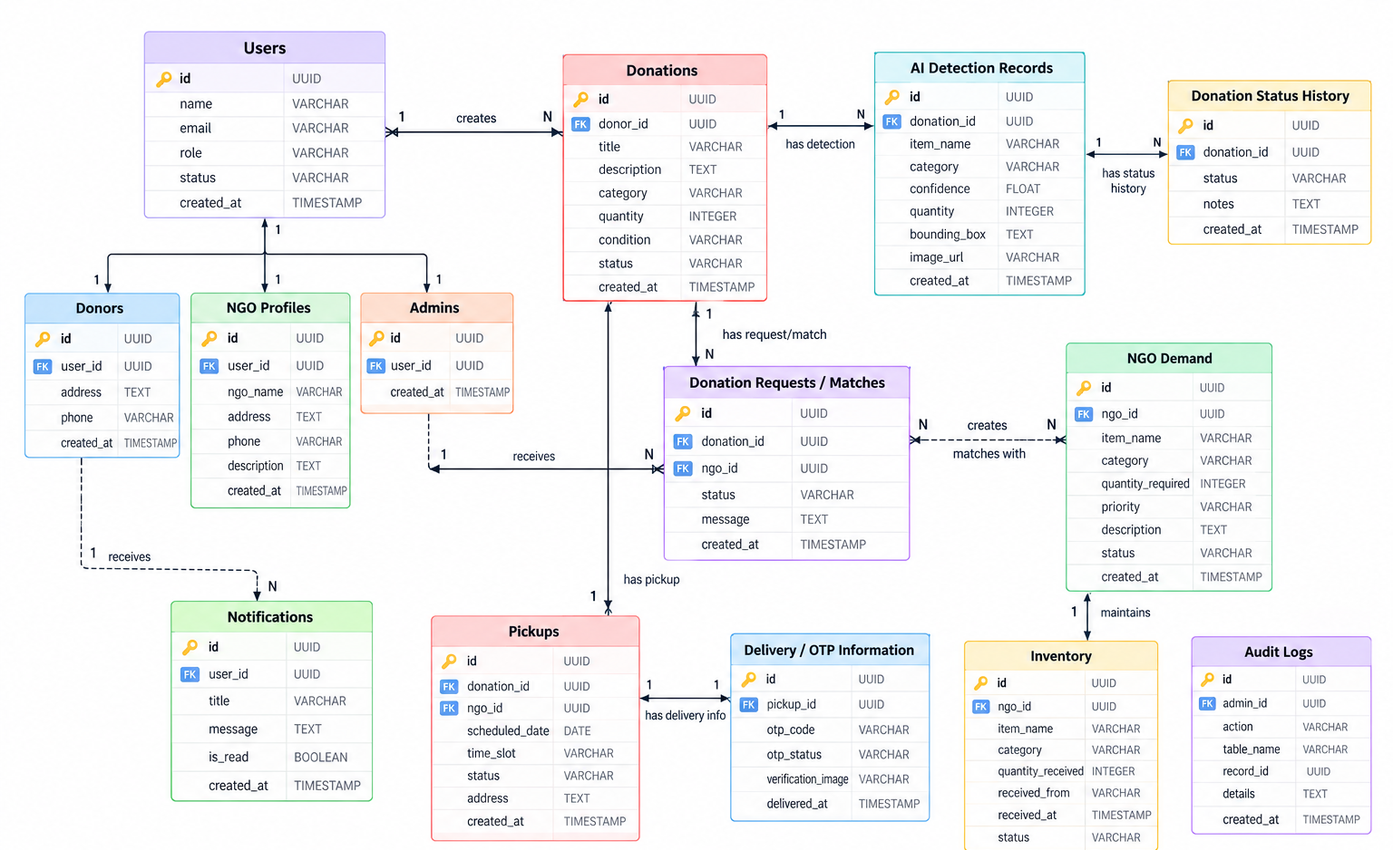
Figure 2: Donation AI Database Entity Relationship Diagram
The entity relationship diagram shows the tables and relationships used by the Donation AI database

6. Snapshots / Screenshots
This section documents the implemented user interfaces and demonstrates the major workflows of the completed application for each user role.

Donor Interface
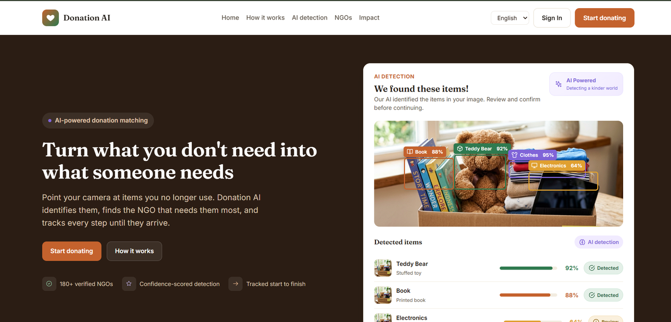
Figure 3: Donation AI Home Page
The landing page introduces the platform with an AI detection preview, language selection and sign-in access.
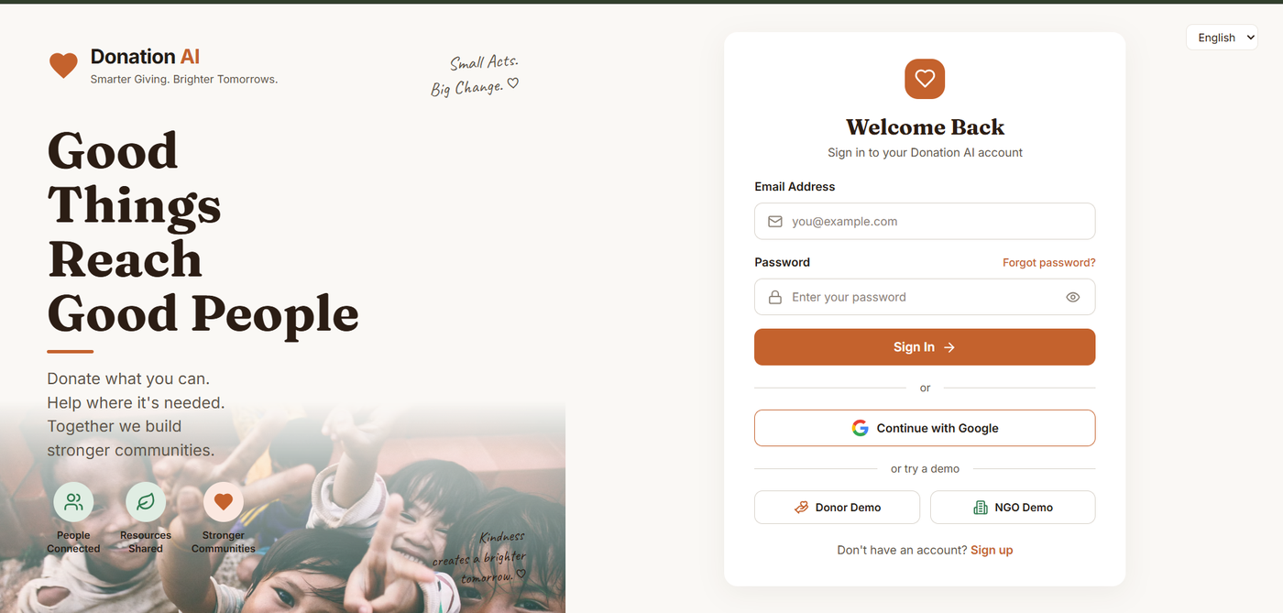
Figure 4: Sign In Page
Users sign in with email and password or Google, with demo access provided for the Donor and NGO roles.
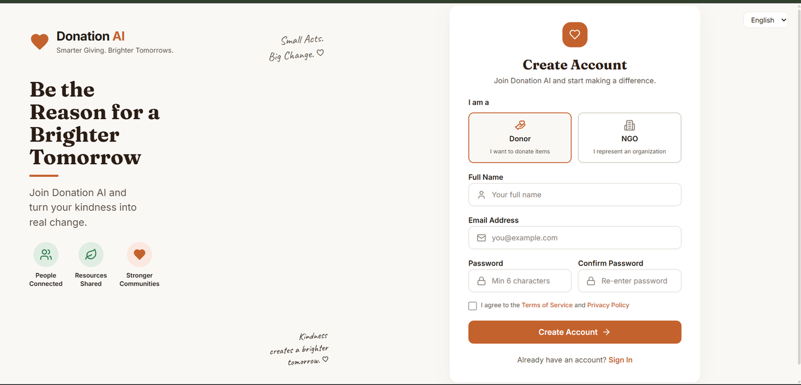
Figure 5: Create Account Page
New users register as a Donor or an NGO by providing their name, email and password and accepting the terms.
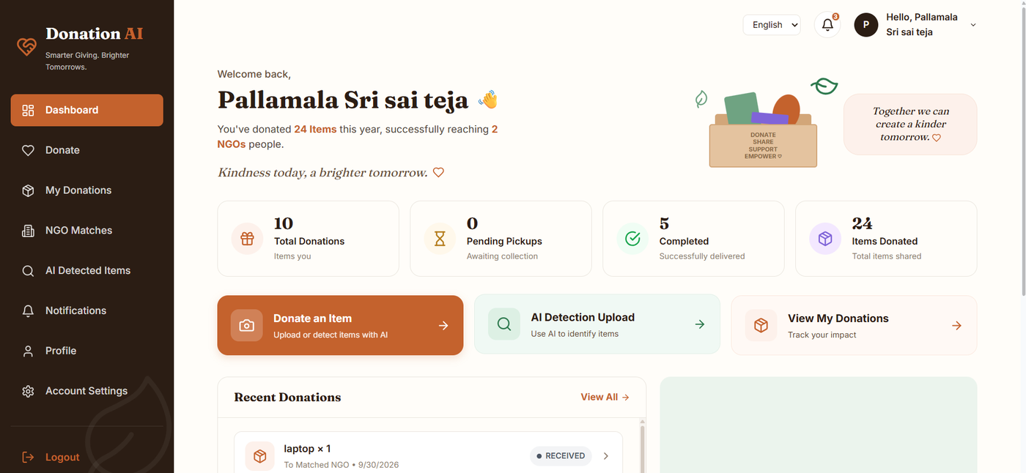
Figure 6: Donor Dashboard
The dashboard summarizes total donations, pending pickups, completed deliveries and items donated, with shortcuts to donate and upload images for AI detection.
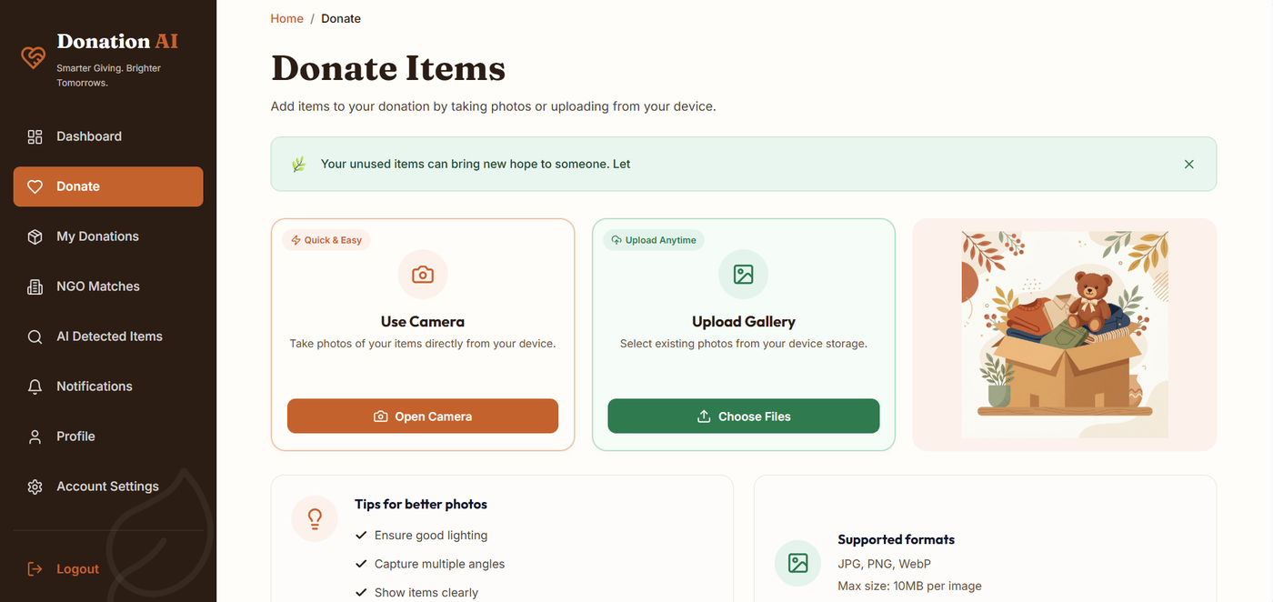
Figure 7: Donate Items Page
Donors add items by taking photos with the camera or uploading images from the device (JPG, PNG or WebP, up to 10 MB per image).
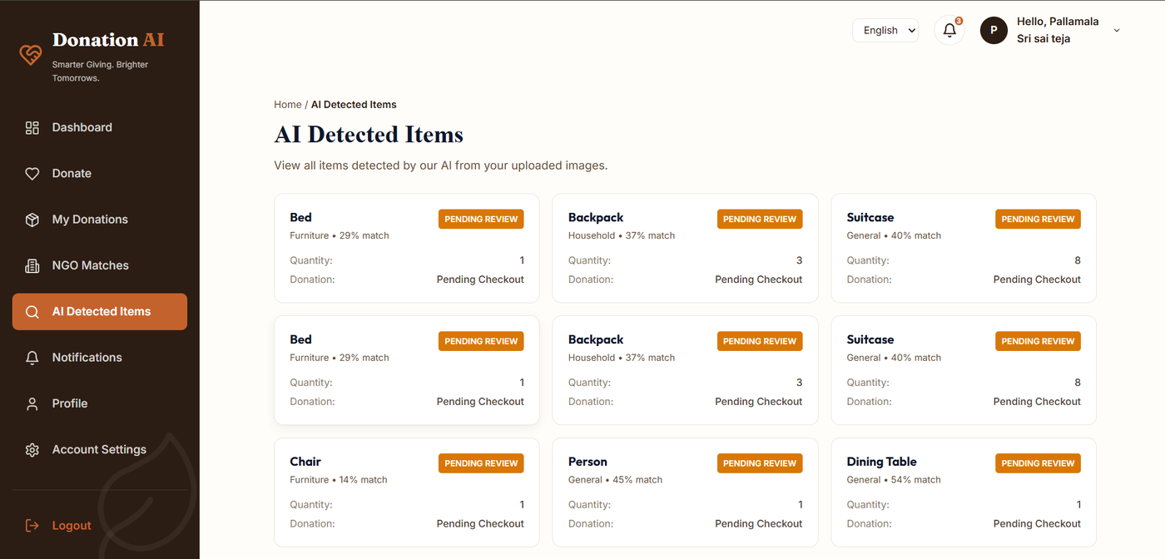
Figure 8: AI Detected Items
Items detected from uploaded images are listed with category, match percentage, quantity and review status.
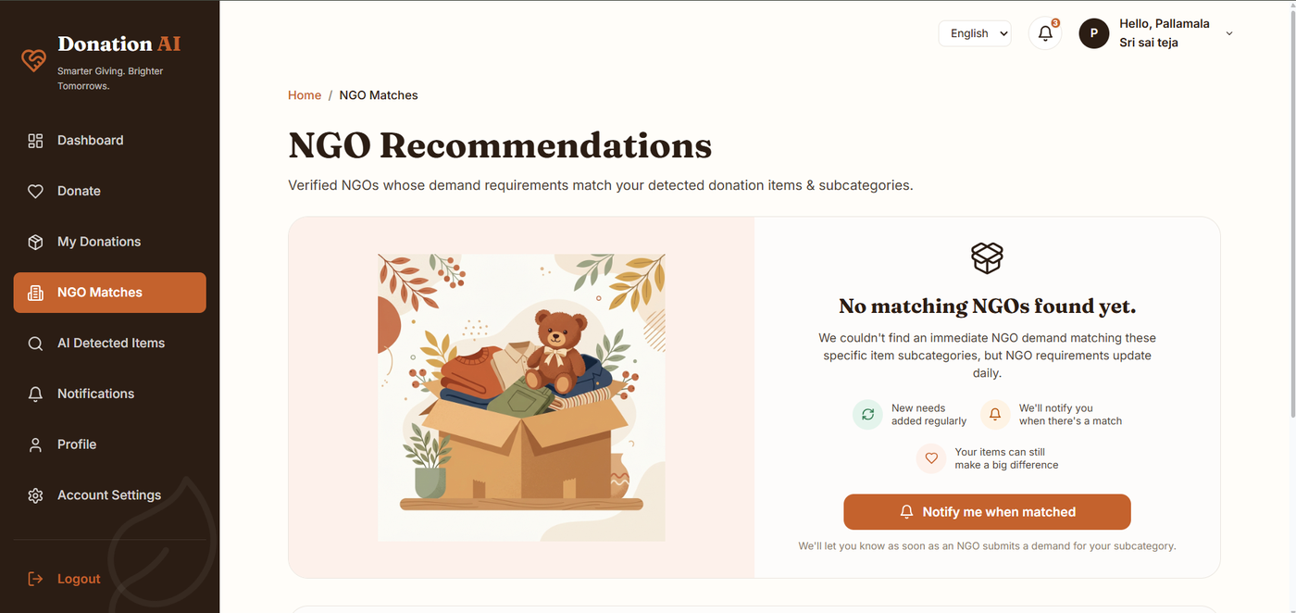
Figure 9: NGO Recommendations
Verified NGOs whose demand matches the detected items are recommended; when none match, the donor can request a notification.
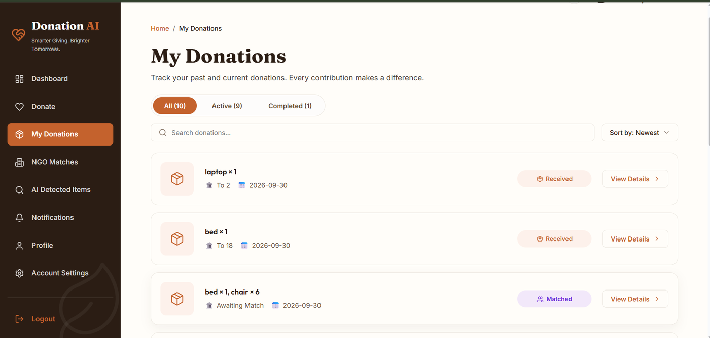
Figure 10: My Donations
Donations can be filtered as All, Active or Completed, searched and sorted, and each shows its items, NGO, date and current status.
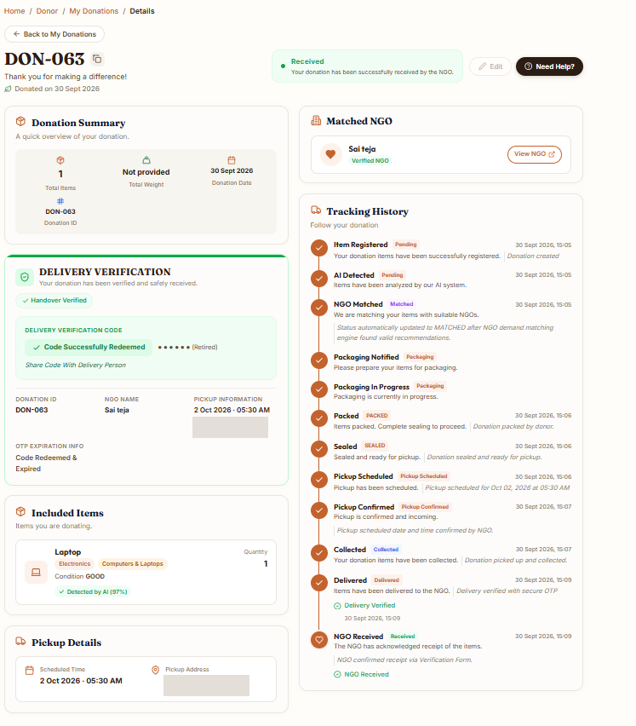
Figure 11: Donation Details
The page shows the donation summary, matched NGO, delivery verification, included items, pickup details and the full tracking history through to NGO receipt. Pickup address is masked.
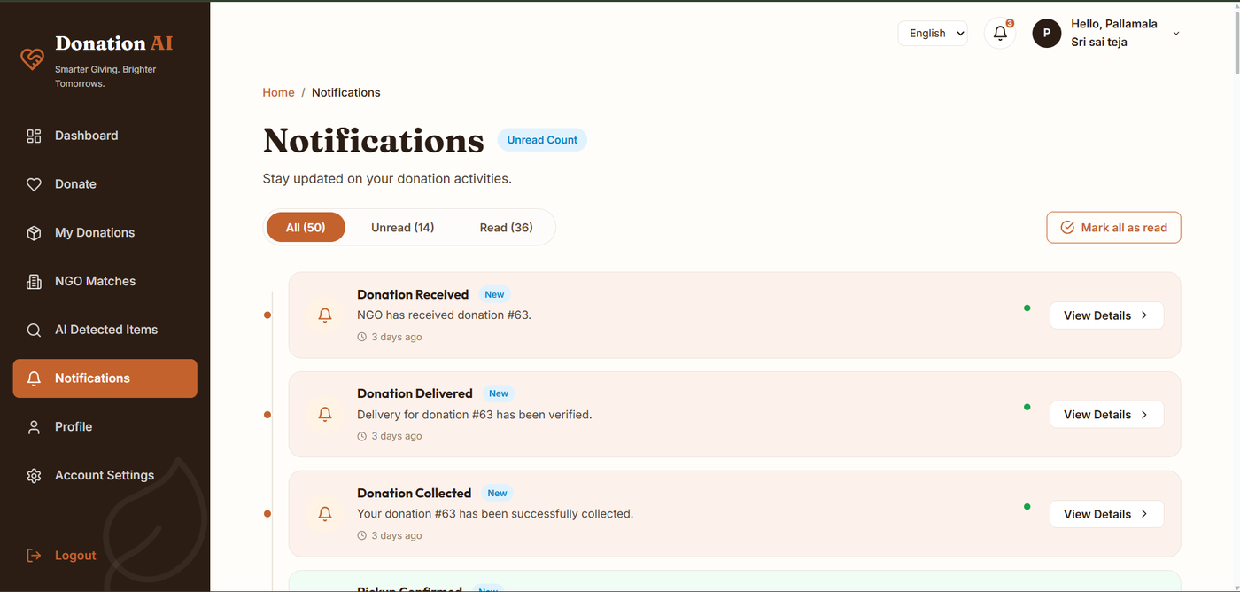
Figure 12: Notifications
Donation events such as collection, delivery verification and receipt by the NGO are listed, with filters for read and unread notifications.
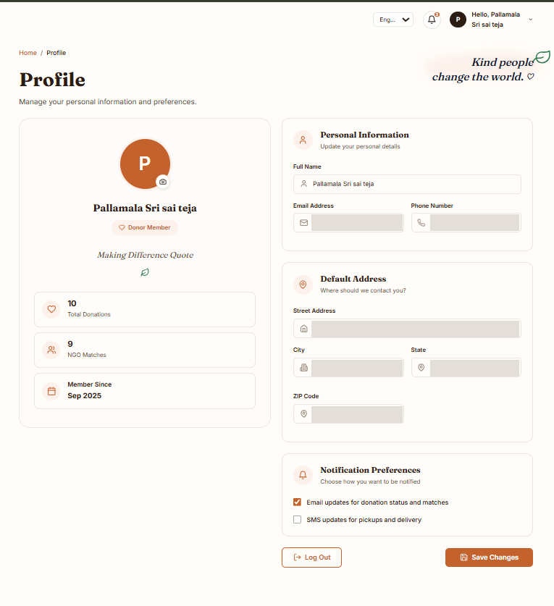  Figure 13: Donor Profile  Donors manage personal information, default address and notification preferences. Contact details are masked. | 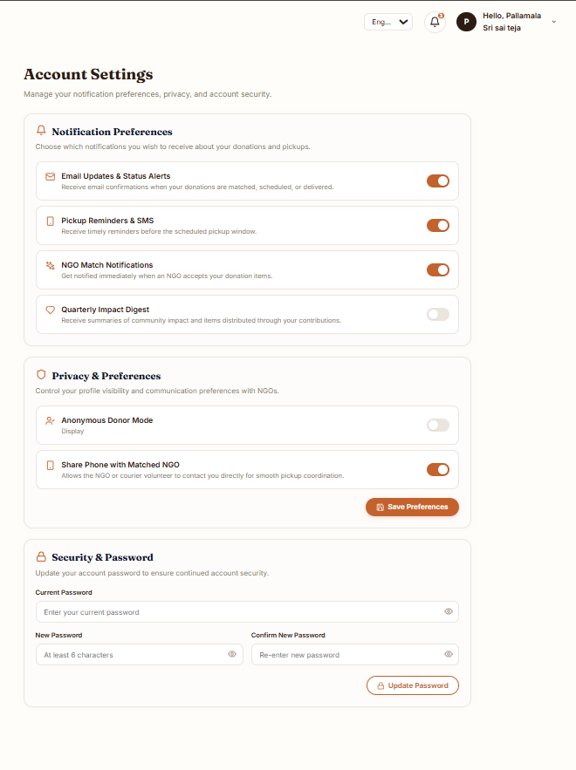  Figure 14: Account Settings  Notification, privacy and security settings, including the option to update the account password.

NGO Interface
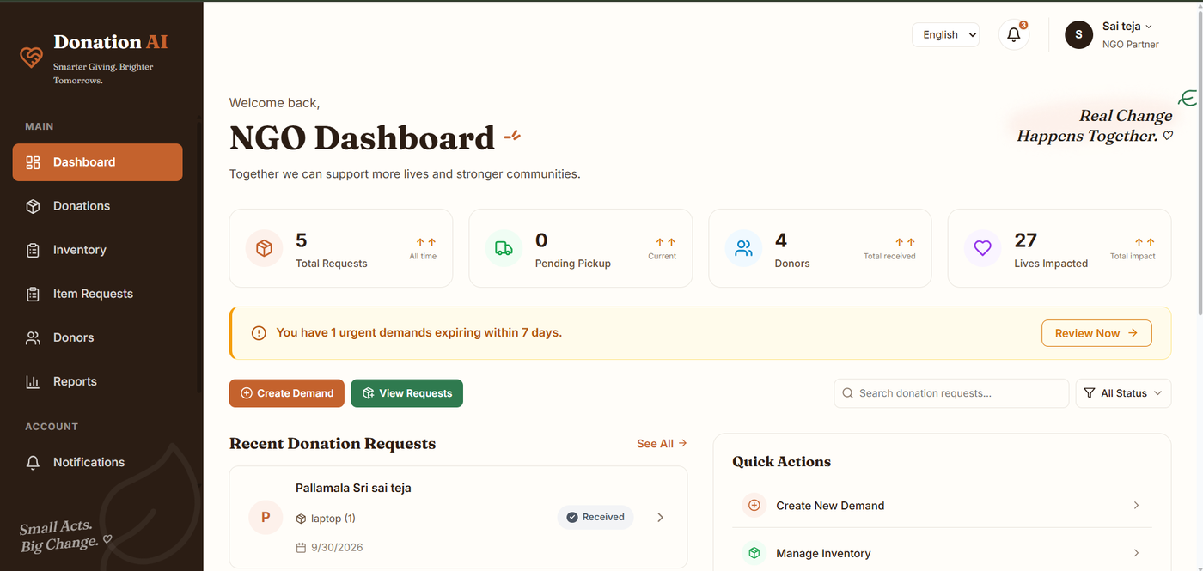
Figure 15: NGO Dashboard
The dashboard summarizes total requests, pending pickups, donors and lives impacted, highlights urgent demands expiring within seven days, and provides quick actions.
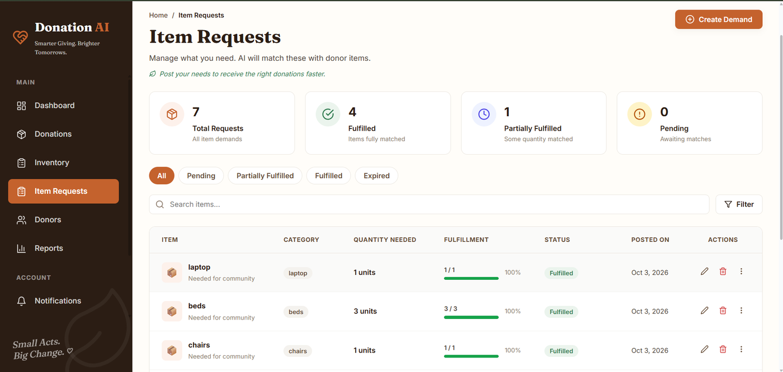
Figure 16: NGO Demand Registry
NGOs post and manage their item demands, with the quantity needed, fulfilment progress, status and posting date.
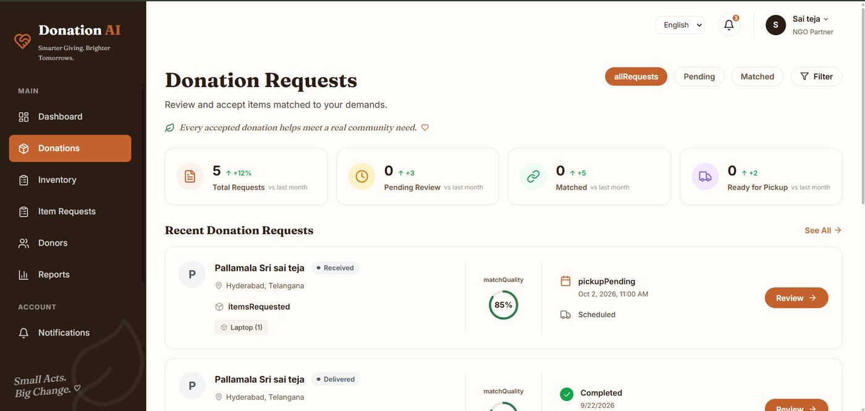
Figure 17: Donation Requests
NGOs review items matched to their demands, with match quality, pickup status and a review action for each request.
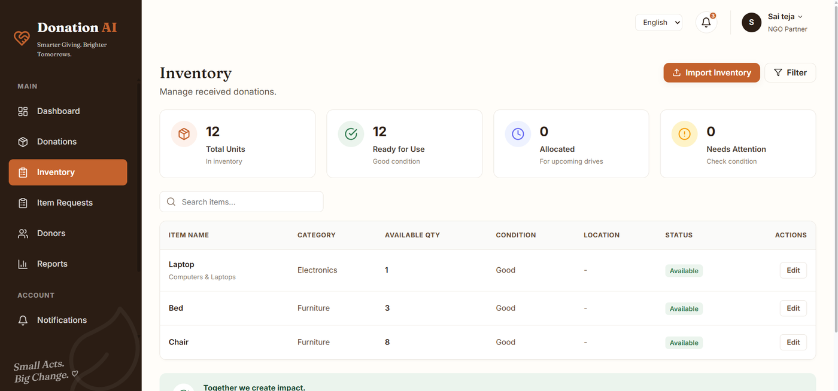
Figure 18: NGO Inventory
The inventory lists received items with category, available quantity, condition and status, and supports search, filtering and editing.
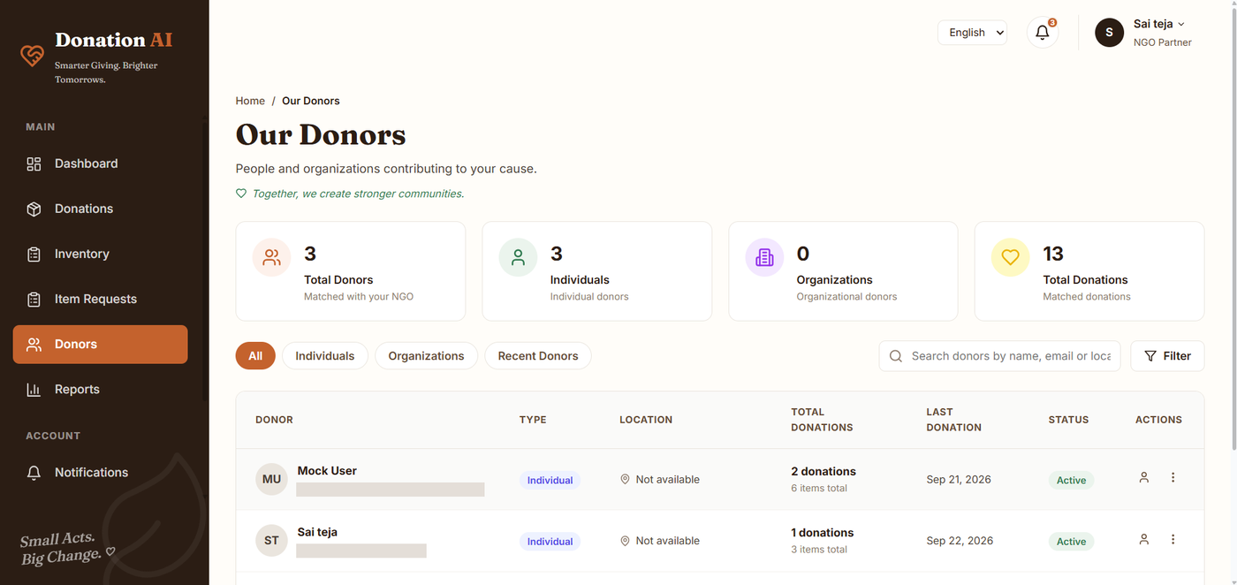
Figure 19: NGO Donors
The page lists donors matched with the NGO, with donor type, location, total donations, last donation and status. Donor email addresses are masked.
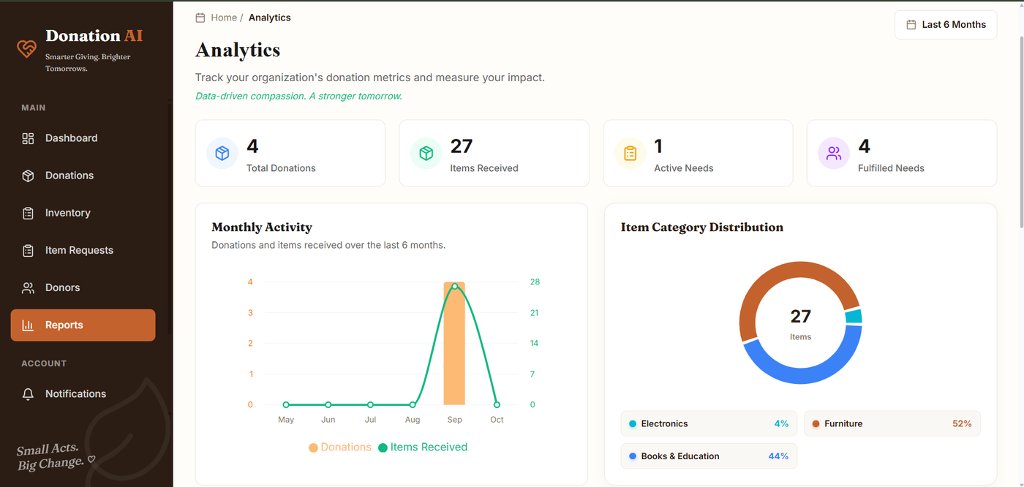
Figure 20: NGO Analytics and Reports
The analytics page shows total donations, items received, active and fulfilled needs, monthly activity and item category distribution.

Admin Interface
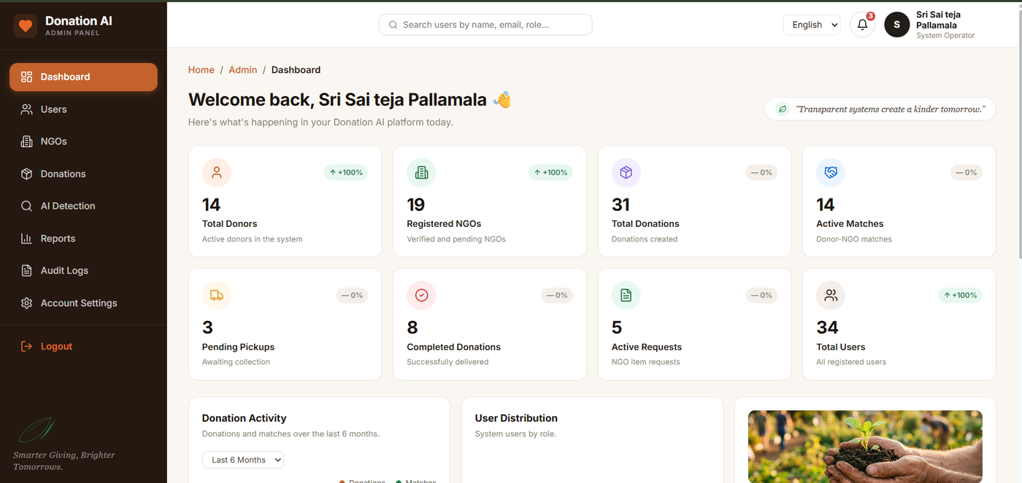
Figure 21: Admin Dashboard
The dashboard presents platform-wide totals for donors, registered NGOs, donations, active matches, pending pickups, completed donations, active requests and users.
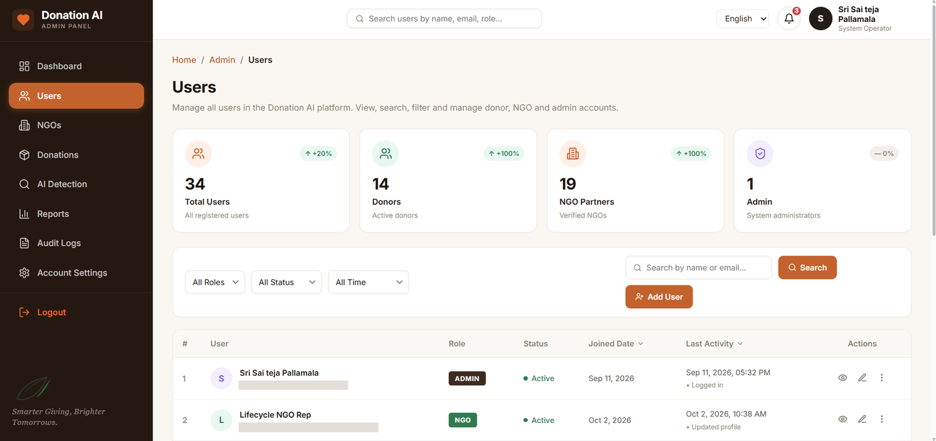
Figure 22: User Management
Administrators view, search and filter donor, NGO and admin accounts by role, status and activity. User email addresses are masked.
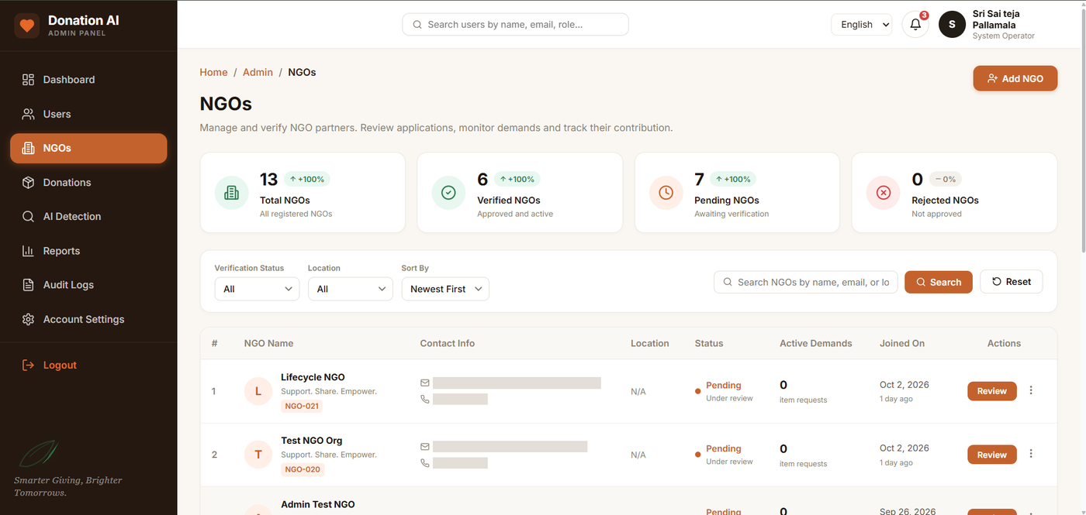
Figure 23: NGO Management
The page supports review and verification of NGO partners, with verification status counts, active demands and join dates. NGO contact details are masked.
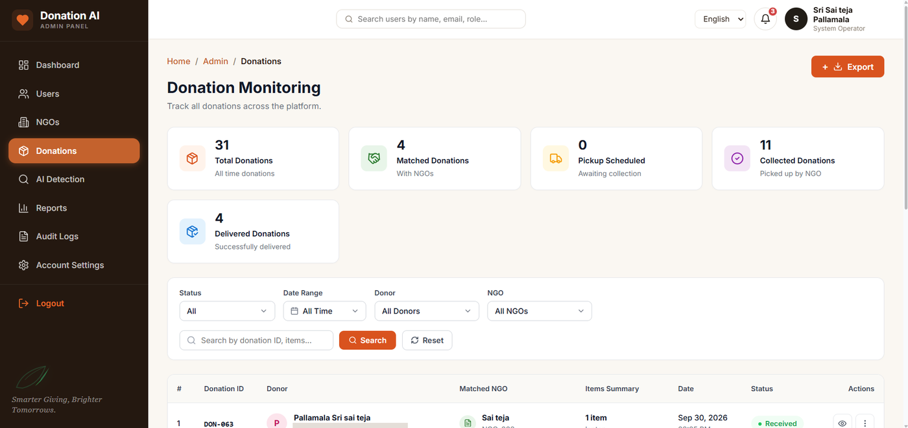
Figure 24: Donation Monitoring
Administrators track all donations across the platform with status counts, filters by status, date, donor and NGO, and a searchable donation list.
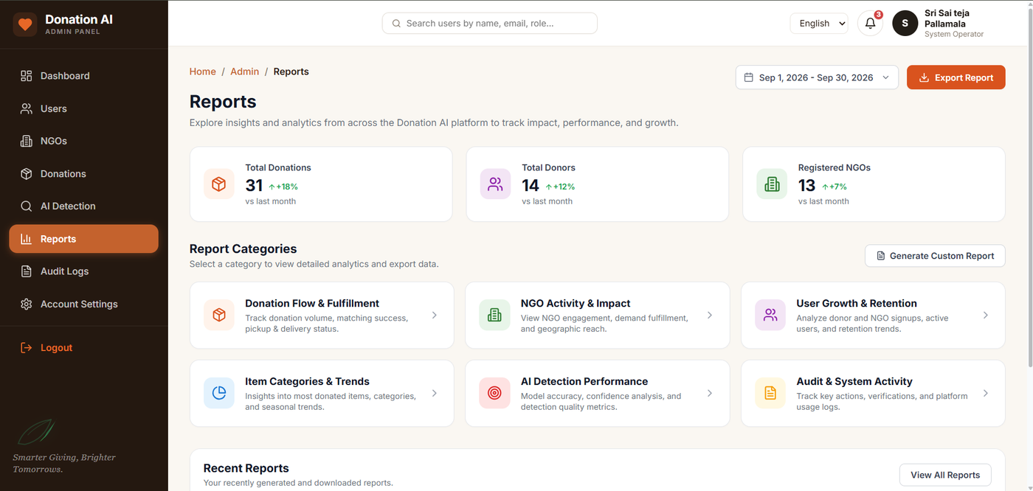
Figure 25: Reports
The reports page provides summary metrics and report categories covering donation flow, NGO activity, user growth, item trends, AI detection performance and audit activity.
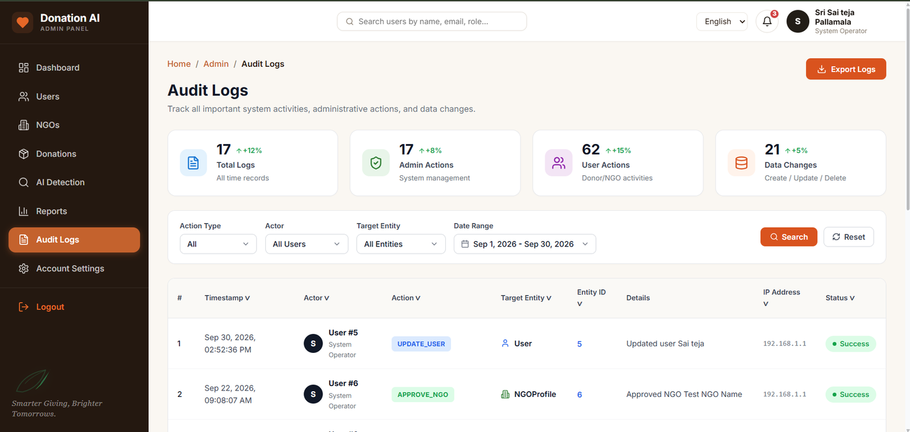
Figure 26: Audit Logs
The audit log records system activities and administrative actions with timestamp, actor, action, target entity and status, with filtering and export options.

API Implementation
The frontend and backend communicate through REST APIs implemented using FastAPI. The APIs cover authentication-related operations, users, donations, AI detection, NGO management, matching, pickups, statuses, notifications, inventory, delivery verification and administrative operations.

Donation APIs
Method | Endpoint | Purpose
POST | /api/donations | Create a donation
GET | /api/donations | Retrieve donations
GET | /api/donations/{donation_id} | View a donation
PATCH | /api/donations/{donation_id} | Update a donation

Pickup APIs
Method | Endpoint | Purpose
GET | /pickup/slots | List available pickup slots
POST | /pickup/donations/{donation_id} | Schedule a pickup
GET | /pickup/donations/{donation_id} | View pickup details
GET | /pickup/ | List pickups
PATCH | /pickup/{pickup_id} | Update pickup status

Donation Status APIs
Method | Endpoint | Purpose
GET | /status/donations/{donation_id} | Retrieve status history
PATCH | /status/donations/{donation_id} | Perform a status transition

Other API Groups
- NGO APIs: NGO information, demand management, donation requests, matching, donor information, pickup coordination, inventory and reports.
- Notification APIs: create and retrieve notifications and maintain notification status.
- AI Detection APIs: receive uploaded images, process them with the YOLOv8 model and return detection information.
- Delivery Verification APIs: manage OTP verification, delivery photo, donation verification, delivery status and NGO receipt.

AI Implementation, Security and SMTP

AI-Based Item Detection
AI-based item detection is one of the primary features of Donation AI. When a donor uploads an image, the FastAPI backend passes it to the YOLOv8 model. The model returns the detected class or item, confidence, quantity and bounding box, which are sent as a detection response to the frontend for display. The results are associated with the corresponding donation and are used in the NGO matching process.

Authentication and Security
Firebase Authentication manages user authentication. The application supports role-based access for Donor, NGO and Admin users, and protected functionality is restricted according to the authenticated user’s role. The delivery workflow additionally uses OTP verification, with the OTP sent through the configured SMTP email service and verified before delivery is completed.

SMTP Email Integration
SMTP is used for delivery-related OTP communication and other supported email functionality. SMTP credentials are maintained on the backend and are not exposed through the frontend interface.

Testing and Validation
Testing was performed progressively across the application. Functional testing covered individual features; integration testing verified communication between the frontend, backend, database, AI model, authentication and email services; and API testing covered requests, responses, authentication, authorization, validation, error handling and database updates. Database changes were verified after important operations, separate workflows were tested for each role, and the complete donation workflow was tested end to end from creation to NGO receipt.

Major Test Cases
Test ID | Test Case | Acquired Result
TC-01 | Donor login | Donor dashboard opens
TC-02 | Create donation | Donation created successfully
TC-03 | Upload donation image | Image accepted
TC-04 | AI detection | Detection result generated
TC-05 | View AI detected items | Correct detection displayed
TC-06 | NGO matching | Relevant NGO information displayed
TC-07 | Packaging checklist | Packaging status updated
TC-08 | Schedule pickup | Pickup created
TC-09 | NGO confirms pickup | Pickup status updated
TC-10 | Donation tracking | Current status displayed
TC-11 | NGO demand creation | Demand stored
TC-12 | Delivery OTP | Valid OTP accepted
TC-13 | Invalid OTP | Verification rejected
TC-14 | NGO received | Donation marked received
TC-15 | Inventory | Received item reflected
TC-16 | Admin users | Users displayed
TC-17 | Admin donations | Donations displayed
TC-18 | Notifications | Correct user notified
TC-19 | Language switching | UI translated
TC-20 | Responsive UI | Interface adapts
TC-21 | PWA installation | Application installable
TC-22 | End-to-end workflow | Complete workflow operates

Multilingual, Responsive and PWA Verification
Language switching across English, Telugu, Hindi, Tamil and Kannada, responsive behavior on different screen sizes, and Progressive Web Application installation were verified as part of the non-functional testing.

Testing Results
The project was tested module by module, followed by integration and regression testing. The areas covered are listed below. The final counts should be entered from the actual test records.
Donor | NGO | Admin | Authentication
Donation Management | AI Detection | NGO Matching | Packaging
Pickup | Tracking | Delivery Verification | Notifications
Inventory | APIs | Database | Multilingual Support
Responsive UI | PWA | Security | End-to-End Workflow

7. Challenges Faced
Area | Challenge | How It Was Addressed
AI Detection | Handling image uploads, model inference, detection responses, confidence values and frontend visualization. | Integrated step by step and verified with test images.
Backend and Database | Keeping frontend actions, FastAPI APIs and PostgreSQL records consistent. | Careful debugging, API testing and database verification.
Pickup Synchronization | Keeping pickup information consistent between Donor and NGO interfaces. | Verified through role-based and end-to-end testing.
OTP Delivery | Secure OTP handling, email delivery, validation, expiry handling and status synchronization. | Validated with valid and invalid OTP test cases.
Authentication | Separating Donor, NGO and Admin functionality. | Role-based access and role-wise testing.
Multilingual Support | Translating five languages consistently while preserving dynamic database values. | Translations managed with i18next and verified on each screen.
Responsive Design | Keeping the interface usable across desktop, tablet and mobile sizes. | Tested at multiple screen sizes.

8. Learnings & Skills Acquired
The project provided practical experience in full-stack application development and AI integration.
Category | Skills and Knowledge
Technical Skills | React.js, Vite, Python, FastAPI, PostgreSQL, SQLAlchemy, REST API development, YOLOv8, Firebase Authentication, SMTP, Docker, Git and GitHub, i18next, PWA development, responsive web development
Development Skills | Frontend and backend development, database design, API integration, authentication and authorization, AI model integration, debugging, error handling, integration testing, deployment concepts
Professional Skills | Requirement analysis, project planning, problem solving, team collaboration, technical communication, documentation, presentation, troubleshooting

9. Testimonials from Team
The Donation AI project provided practical experience in transforming a real-world problem into a functional technology solution. The development process helped the team understand how artificial intelligence, web development, databases, authentication, APIs and external services can be integrated into one complete application. The internship also provided valuable experience in testing, debugging, documenting and presenting a complete software project.
Pallamala Sri Sai Teja

10. Conclusion
The Donation AI project demonstrates a complete technology-driven approach to managing the donation lifecycle. The application connects donors and NGOs through a centralized platform and uses AI-based item detection to assist in identifying donated resources. NGO demand information supports resource matching, while pickup scheduling, tracking, delivery verification, notifications and inventory management provide a structured workflow after a donation is registered.
The project integrates React.js, FastAPI, PostgreSQL, YOLOv8, Firebase Authentication, SMTP, i18next, Docker and PWA technologies, and gave practical experience in full-stack software engineering, AI integration, database management, API development, authentication, testing and debugging. The completed application shows how software and AI can be combined to address a real-world resource distribution problem through a structured digital platform.

11. Acknowledgements
We would like to express our sincere gratitude to Infosys Springboard for providing the opportunity to participate in the Virtual Internship 7.0 program. We are thankful to the mentors and coordinators who provided guidance, feedback and support throughout the internship and project development.
We also thank everyone who supported us during the planning, development, testing, documentation and final presentation of the Donation AI project. The internship gave us the opportunity to apply our technical knowledge to a practical project and gain valuable experience in software development, artificial intelligence, database management, testing and professional documentation.

